**DAILY ONLINE ACTIVITIES SUMMARY**

|  |  |  |  |  |  |  |  |  |
| --- | --- | --- | --- | --- | --- | --- | --- | --- |
| **Date:** | | **26-06-2020** | | | | **Name:** | **Raksha S** | |
| **Sem & Sec** | | **6th -B** | | | | **USN:** | **4AL17CS073** | |
| **Online Test Summary** | | | | | | | | |
| **Subject** | | | **Cyber Security and Data Structures in C** | | | | | |
| **Max. Marks** | | | **-** | **Score** | | | **-** | |
| **Pre-placement Training Summary** | | | | | | | | |
| **Topic** | **Cyber Security,**  **Data Structures in C** | | | | | | | |
| **Faculty** | Dr. Manjunath Kotari  Venkatesh Bhat | | | | **Duration** | | | **4hours** |
| **Coding Challenges** | | | | | | | | |
| **Problem Statement**:  1. Write a program to print all permutations of a given string.  **2. Python Program to Read the Contents of a File in Reverse Order** | | | | | | | | |
| **Status: Solved** | | | | | | | | |
| **Uploaded the report in Github** | | | | | **yes** | | | |
| **If yes Repository name** | | | | | https://github.com/raksha05/Daily-Status/Raksha-4AL17CS073/Raksha | | | |
| **Uploaded the report in slack** | | | | | **yes** | | | |

**SNAPSHOTS**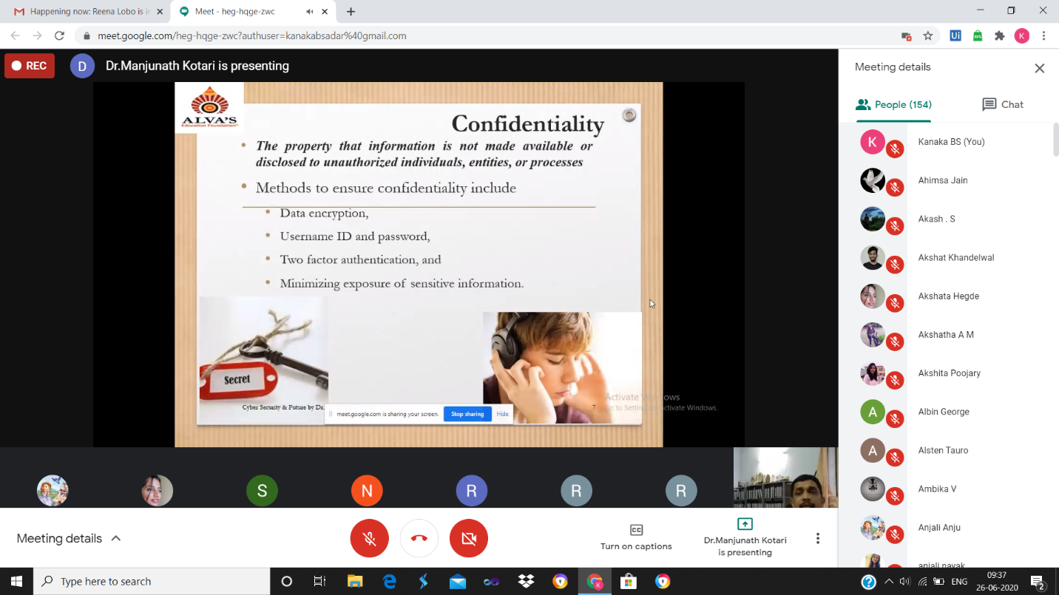

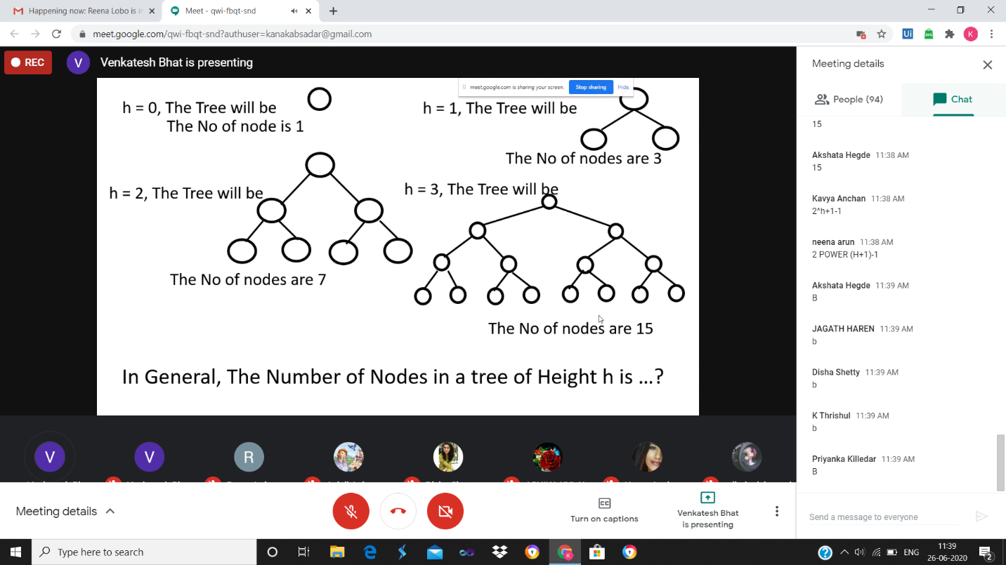

**ONLINE CODING**

**1. Write a program to print all permutations of a given string.**

public class Permutation {

public static void main(String[] args)

{

String str = "ABC";

int n = str.length();

Permutation permutation = new Permutation();

permutation.permute(str, 0, n - 1);

}

private void permute(String str, int l, int r)

{

if (l == r)

System.out.println(str);

else {

for (int i = l; i <= r; i++) {

str = swap(str, l, i);

permute(str, l + 1, r);

str = swap(str, l, i);

}

}

}

public String swap(String a, int i, int j)

{

char temp;

char[] charArray = a.toCharArray();

temp = charArray[i];

charArray[i] = charArray[j];

charArray[j] = temp;

returnString.valueOf(charArray);

}

}

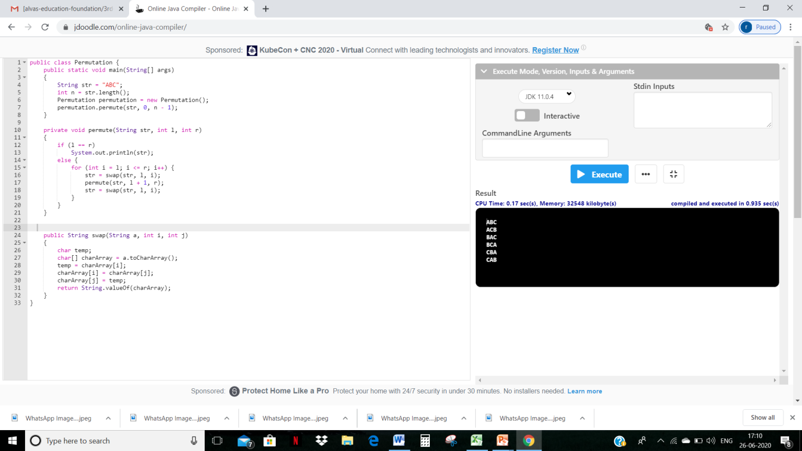

**2. Python Program to Read the Contents of a File in Reverse Order**

**filename=input("Enter file name: ")**

**with open (filename,'r') as f:**

**for line in f:**

**l=line.split()**

**l.reverse()**

**out= " ".join(l)**

**print (out)**

